**DATE:06.08.25**

**TASK:3**

**Implementation of A * Algorithm to find the optimal path**

**AIM**

To implement the A* (A-Star) Search Algorithm using Python to find the optimal shortest path between a start node and a goal node in a weighted graph, using both the actual path cost and a heuristic estimate (Manhattan or straight-line distance).

**ALGORITHM**

1. Start at the starting point on the map.

2. Write down the cost to reach this point from the start (g = 0), and estimate how far it is from the goal using straight lines or grid steps (h = heuristic).  
Then calculate the total cost:  
f = g + h.

3. Look at all the neighbouring points you can go to from your current position.

4.For each neighbour:

* Add the cost to get there from where you are now (g).
* Estimate how far it is from the goal (h).
* Add them to get the total cost: f = g + h.
* Write down this total cost for each possible path.

5.Pick the point with the lowest total cost (f) and go there next.

6. Repeat the process:

* Check all neighbouring points from your current position.
* Update their g, h, and f values.
* Always move to the next point with the lowest f value.

7.Stop when you reach the goal.

8.Trace back the path you took to get the full route from start to goal.

**PROGRAM**

**A* Algorithm on a Graph**

import heapq

# Graph: adjacency list with edge costs

graph = {

'A': [('B', 1), ('C', 4)],

'B': [('D', 5), ('E', 12)],

'C': [('F', 3)],

'D': [('G', 2)],

'E': [('G', 3)],

'F': [('G', 5)],

'G': []

}

# Heuristic values (estimated cost from node to goal)

heuristic = {

'A': 7,

'B': 6,

'C': 5,

'D': 3,

'E': 2,

'F': 4,

'G': 0

}

# A* Algorithm

def a_star(graph, start, goal):

open_list = []

heapq.heappush(open_list, (0 + heuristic[start], 0, start, [start])) # (f, g, current_node, path)

visited = set()

while open_list:

f, g, current, path = heapq.heappop(open_list)

if current in visited:

continue

visited.add(current)

# Goal reached

if current == goal:

print("Optimal Path Found:", " → ".join(path))

print("Total Cost:", g)

return

# Explore neighbors

for neighbor, cost in graph[current]:

if neighbor not in visited:

new_g = g + cost

new_f = new_g + heuristic[neighbor]

heapq.heappush(open_list, (new_f, new_g, neighbor, path + [neighbor]))

print("No path found.")

# Run the algorithm

start_node = 'A'

goal_node = 'G'

a_star(graph, start_node, goal_node)

**OUTPUT**

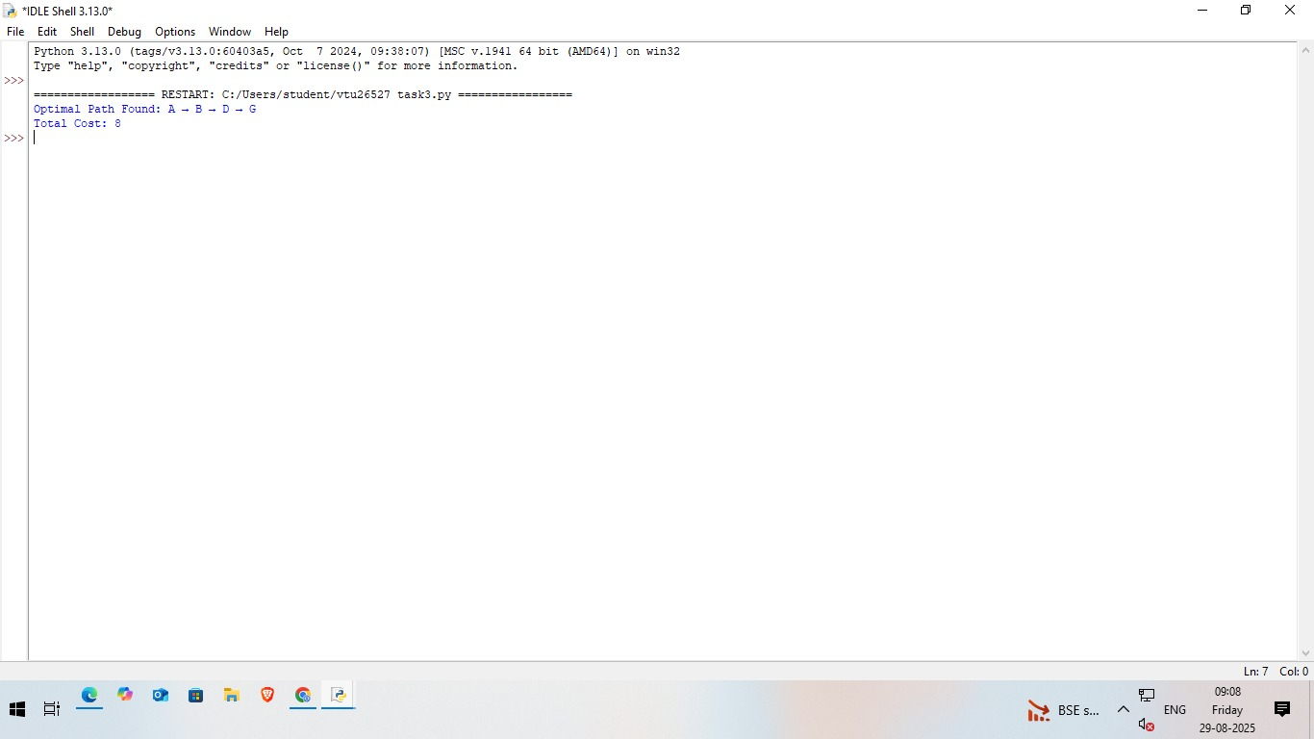

**RESULT**

Thus, the Implementation of A * Algorithm to find the optimal path using Python Was successfully executed and output was verified.